Practical-3

Aim: Write an HTML code for creating a page that contains atleast two
Frames. One frame contain hyperlink to various pages and other frame should display appropriate page.

frame.html

<html>
<head>
</head>
<frameset cols="20%,80%">
<frame src="index.html">
<frame src="main.html" name="display">
</frameset>
</frameset>
</html>

Output:

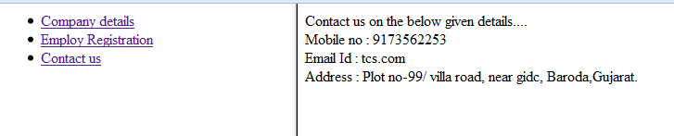

index.html
<html>
<head>
</head>
<body>
<ul>
<li>
<a href="company.html" target=display>Company details</a>
</li>
<li>
<a href="register.html" target=display>Employ Registration</a>
</li>
<li>
<a href="Contact.html" target=display>Contact us</a>
</li>
</ul>
</body>
</html>

Output:

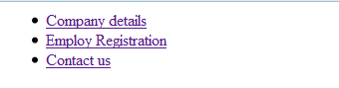

company.html

<html>
<head>
</head>
<frameset cols="35%,60%">
<frame src="image.html">
<frame src="info.html">
</frameset>
</html>

Output:

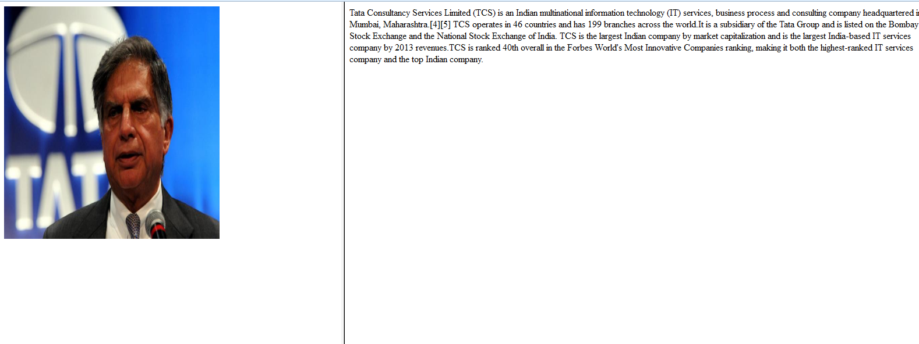

image.html

<html>
<head>
</head>
<img src="image.jpg" height=400 width=370>
</html>

Output:



info.html

Tata Consultancy Services Limited (TCS) is an Indian multinational information technology (IT) services, business process and consulting company headquartered in Mumbai, Maharashtra.[4][5] TCS operates in 46 countries and has 199 branches across the world.It is a subsidiary of the Tata Group and is listed on the Bombay Stock Exchange and the National Stock Exchange of India. TCS is the largest Indian company by market capitalization and is the largest India-based IT services company by 2013 revenues.TCS is ranked 40th overall in the Forbes World's Most Innovative Companies ranking, making it both the highest-ranked IT services company and the top Indian company.

Output:

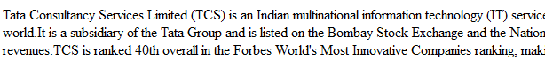

register.html
<html>
<head>
</head>
<body>
<form>
<table border=2>
<tr>
<td><center><b>Employ Registration Form</b></center></td>
</tr>
<tr>
<td colspan=1><fieldset>
<legend><b>Personal Details</b></legend>First Name
<input type="text"><br>
Last Name
<input type="text"><br>
Birth Date<input type="text"><br>

Gender<input type="radio" name=r1>Male
<input type="radio" name=r1>Female<br>

City<select>
<option value="Ahemdabad">Ahemdabad</option>
<option value="Baroda">Baroda</option>
<option value="Surat">Surat</option>
<option value="Ankleshwar">Ankleshwar</option>
<option value="Bharuch">Bahruch</option>
<option value="Bombay">Bombay</option>
<option value="Valsad">Valsad</option>
</select>
State<select>
<option value="Gujarat">Gujarat</option>
<option value="Maharashta">Maharashta</option>
<option value="Uttar pradesh">Uttar pradesh</option>
<option value="Punjab">Punjab</option>
<option value="Madhya pradesh">Madhya pradesh</option>
<option value="Kerela">Kerela</option>
</select>
Country<select>
<option value="Pakistan">Pakistan</option>
<option value="India">India</option>
<option value="Australia">Australia</option>
<option value="America">America</option>
<option value="Dubai">Dubai</option>
</select>
</fieldset>
</td>
</tr>
<tr>
<td>
<fieldset><legend><b>Professional Details</b></legend>
Profession<input type="text"><br>
Experience<input type="text">Years<input type="text"><br>
Collage Name<input type="text"><br>
School Name<input type="text">
</fieldset>
</td>
</tr>
<tr>
<td>
<fieldset><legend><b>Contact Information</b></legend>
Home Address<input type="text"><br>
Home Phone<input type="text"><br>
Mobile Phone<input type="text"><br>
E-Mail<input type="text">
</fieldset>
</td>
</tr>
<tr>
<td><input type="button" value=Submit>
<input type="button"value=Reset>
<input type="button"value=Close>
</fieldset>
</td>
</tr>
</body>
</html>

Output:

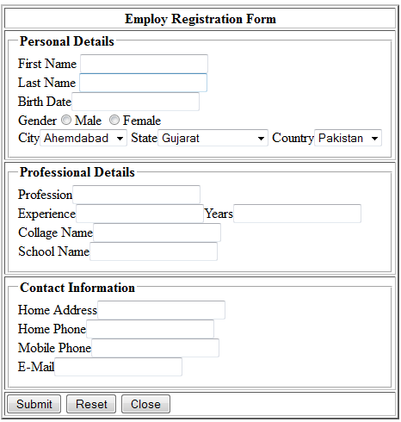

contact.html

<html>
<head>
</head>
<body>
Contact us on the below given details....<br>
Mobile no : 9173562253<br>
Email Id : tcs.com<br>
Address : Plot no-99/ villa road,
near gidc,
Baroda,Gujarat.
</body>
</html>

Output:

